**AWS**

*May 9, 2023*

SLA – Service Level Agreement

SLI – Service Level Indicator

SLO – Service Level Objective

SLC – Service Level Commitment

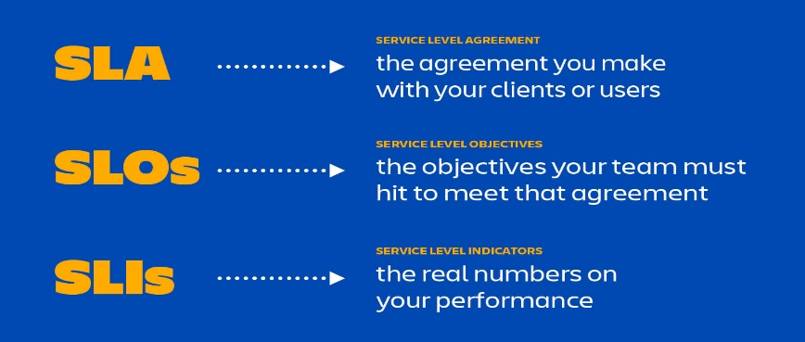

What is Site Reliability Engineering (SRE)?

SRE is what you get when you treat operations as if it’s a software problem. Our mission is to protect, provide for, and progress the software and systems behind all of Google’s public services — Google Search, Ads, Gmail, Android, YouTube, and App Engine, to name just a few — with an ever-watchful eye on their availability, latency, performance, and capacity.

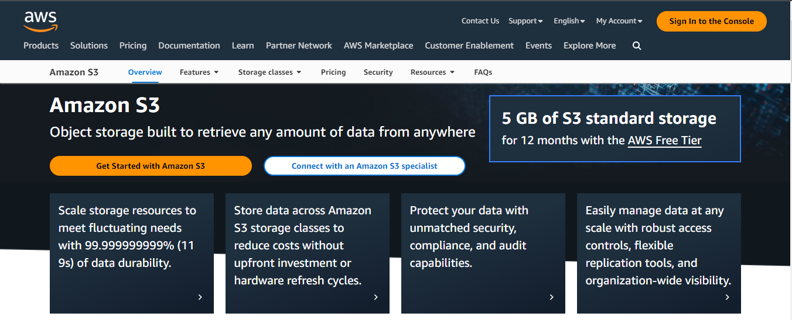

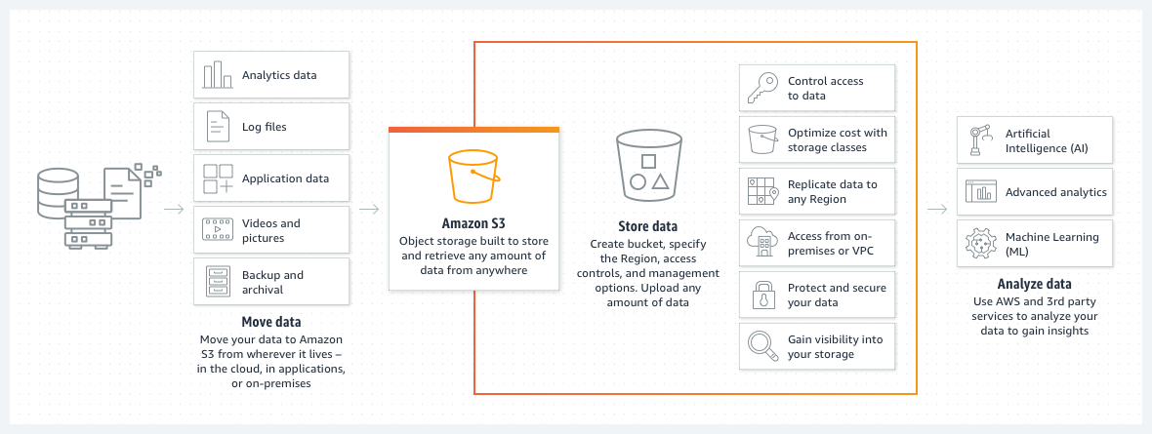

Permission in the AWS Buckets are managed in the ACL – Access Control List in the Permissions tab

**AWS Buckets:**

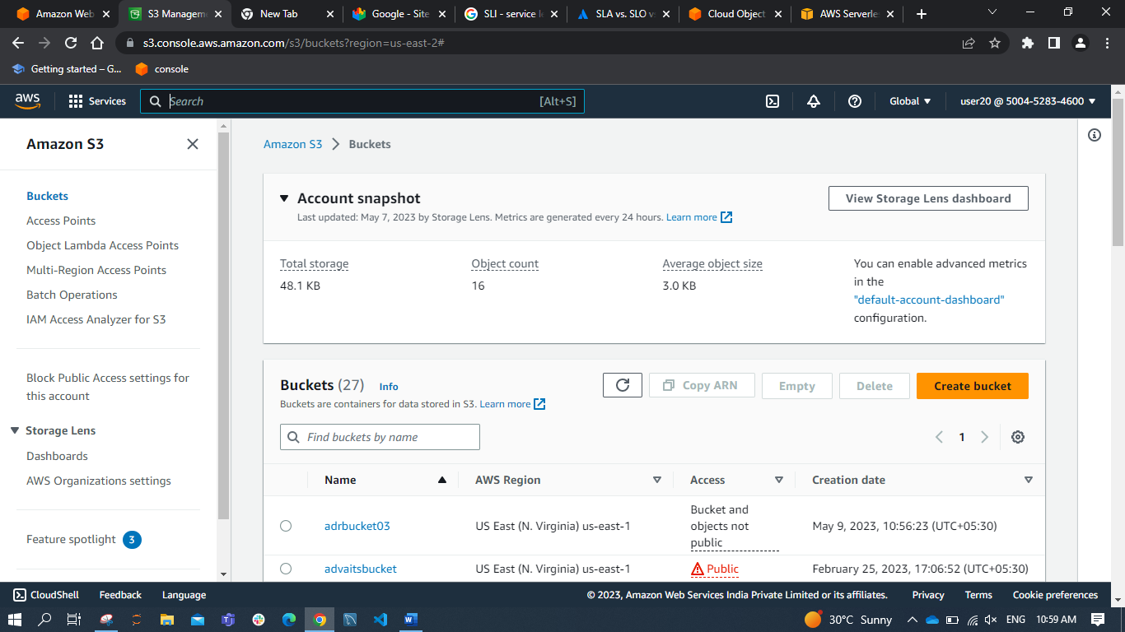

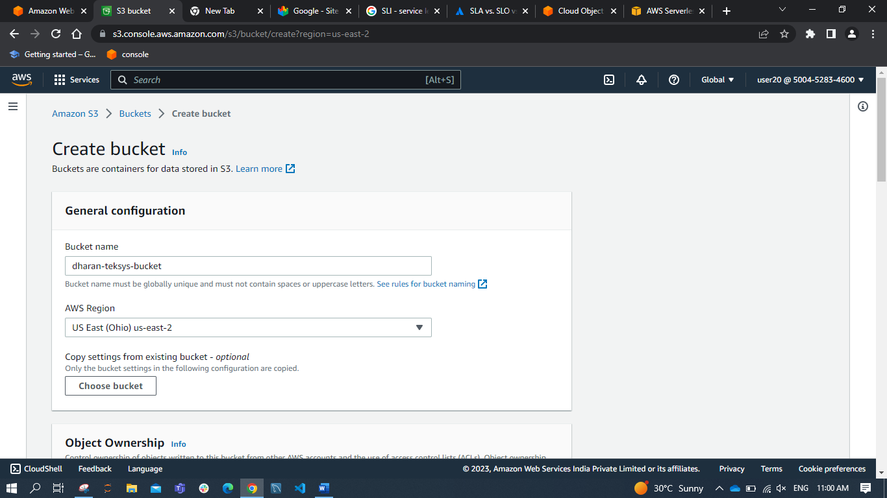

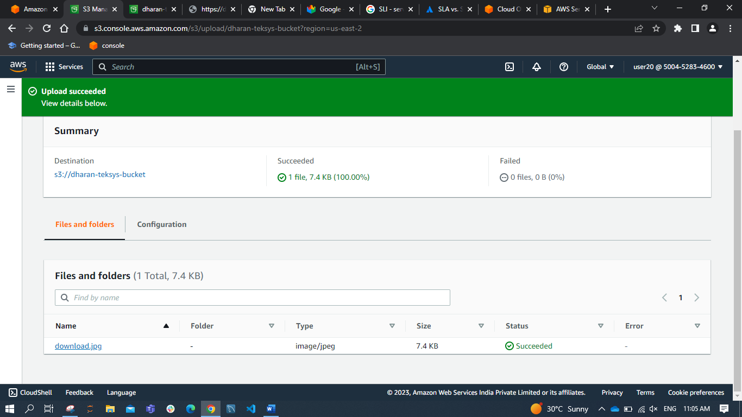

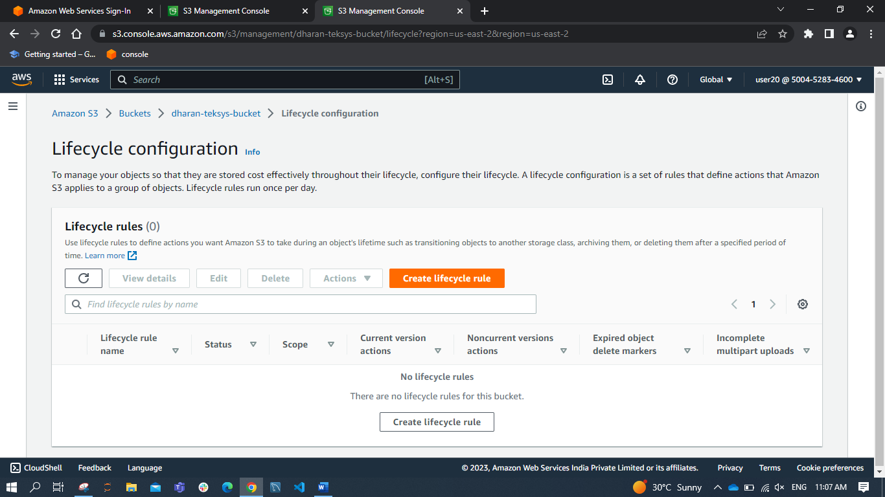

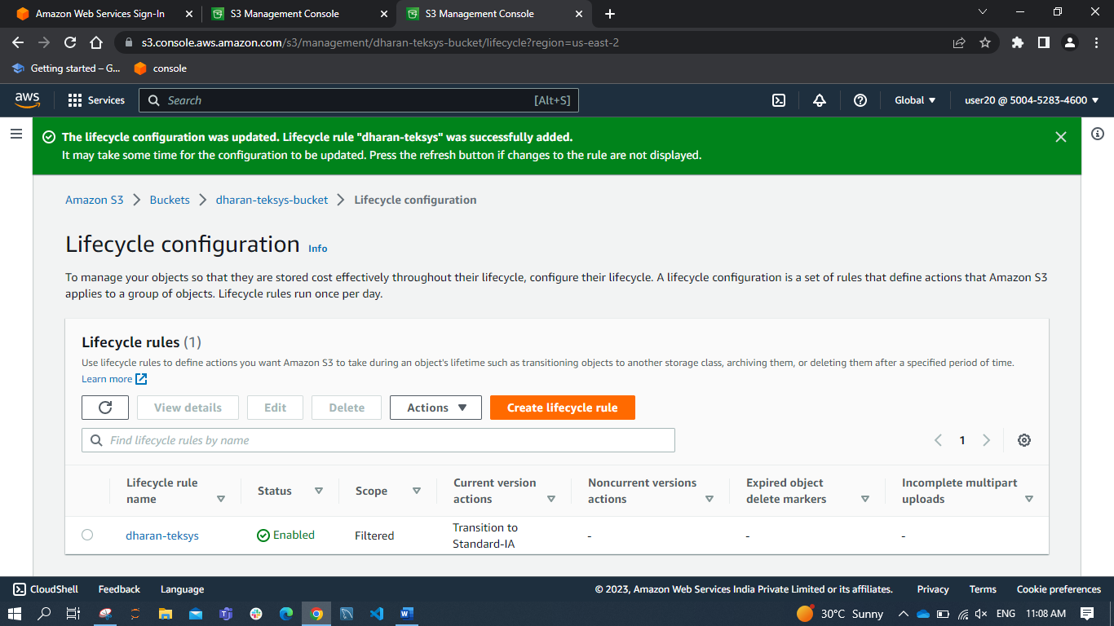



**Instance:**

Amazon EC2

Secure and resizable compute capacity to support virtually any workload

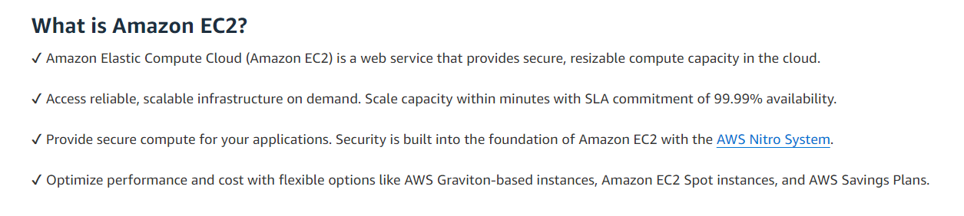

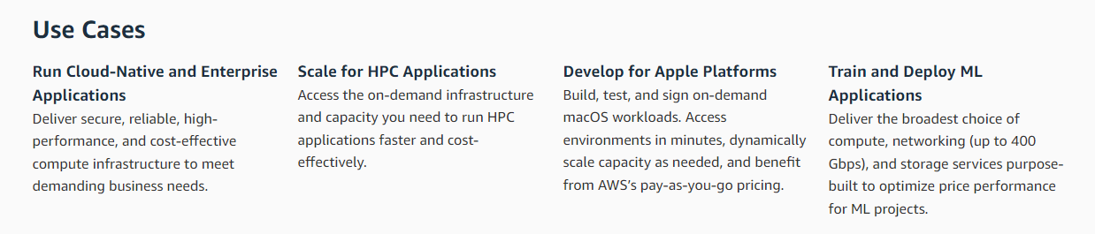

Practice Screenshot:

